Hi, Students Download ISO IMG and VMware Workstation
RHEL7.0 iso img link
https://drive.google.com/file/d/1ChLtTjczdXxC8Nr3SDzZ23ajVrK2Cb-H/view?usp=drive_link
VMware Workstation 17.0 Link
https://drive.google.com/file/d/1vKBPpWPMGExJsTk9rR2gQ69xRMiDDHbU/view?usp=sharing
Open Vmware workstation > create a NEW VM. Then select typical
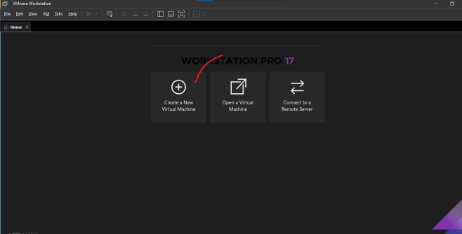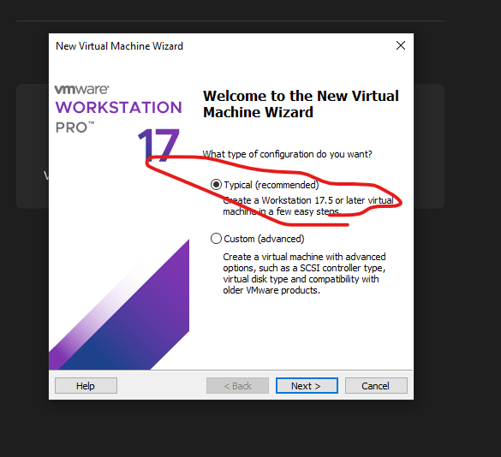
We can install the OS using three option , her will go with third option.
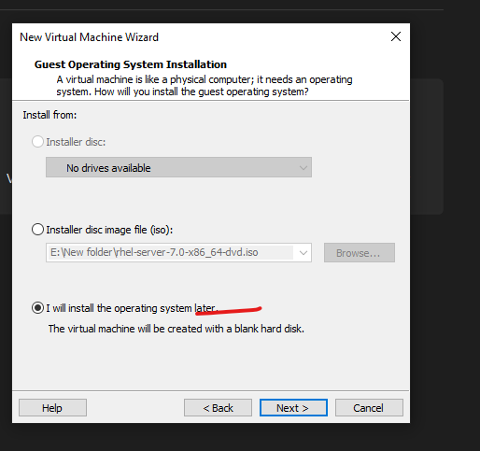
Give VM name and location where it will get store.
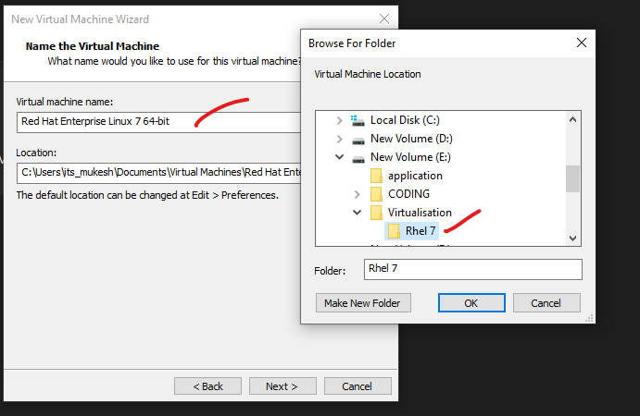
Then give total disk size that OS will needed.
Select the first option . (if we want to store huge data then only select the second option)
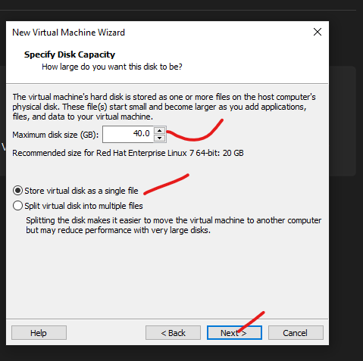
After selecting Cust Hardware option , as per the requirement and Host capacity give the below values.
Memory – 2 gb
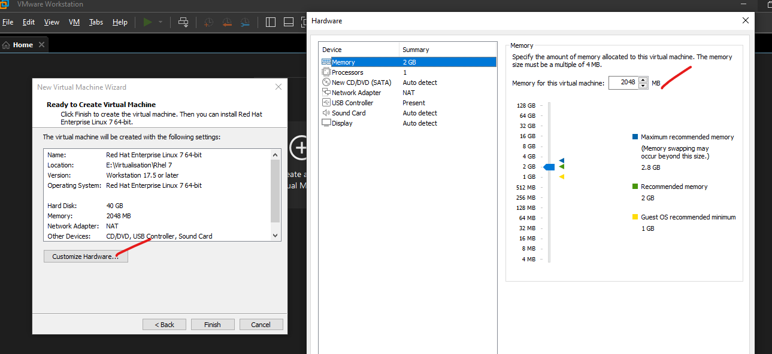
Processor – 3
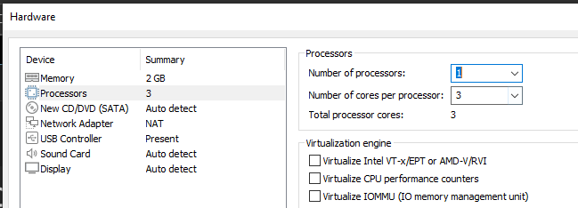

You can browes and select the Rhel 7 ISO image
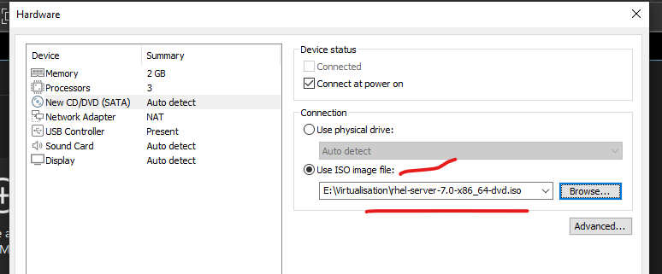

This will use host network for the internet access . and keep everything same and close
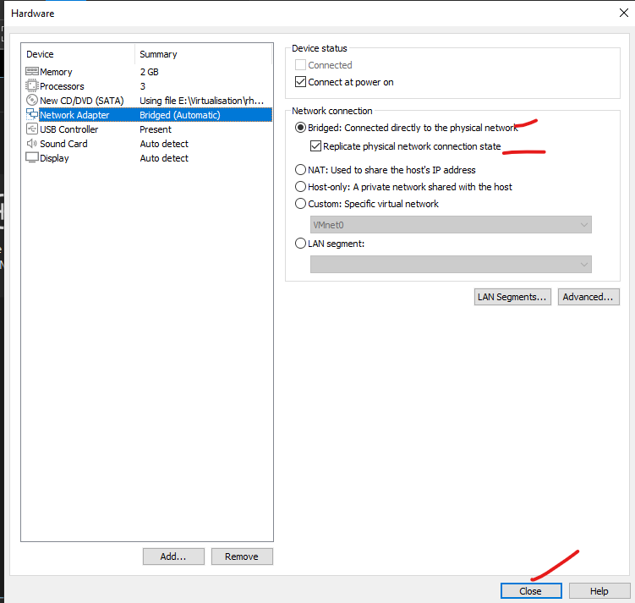
Then finish the configuration .And then a new VM will appear on the Vmware . start the VM.
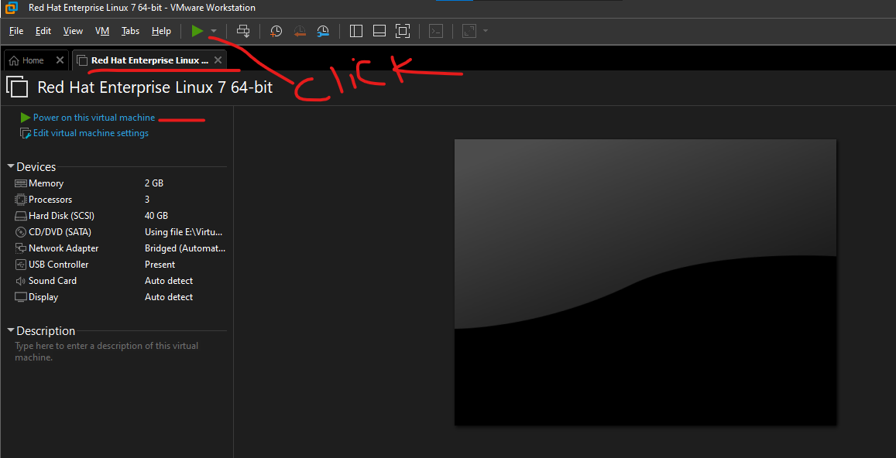

Click the screen and using up arrow key( ) select install Red hat enterprise linux 7.0 .
Click enter . and wait for sometime for installation.
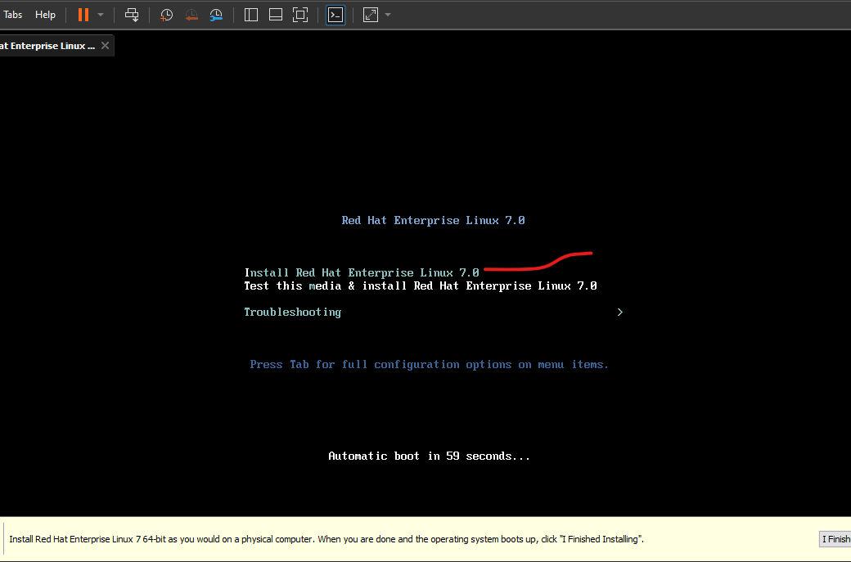
Select language
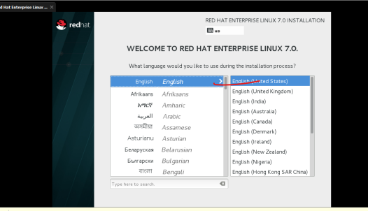
Select date and time , then configure . by selecting the time zone . then click done . 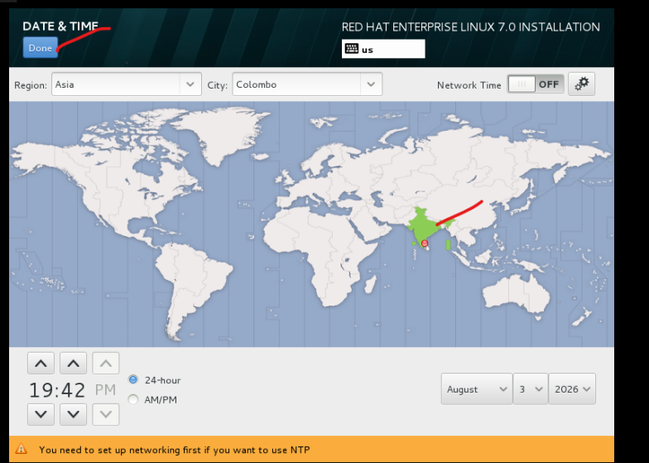

Since we have already given the ISO source , no need to provide any thing . other wise we have to mention the ISO source .
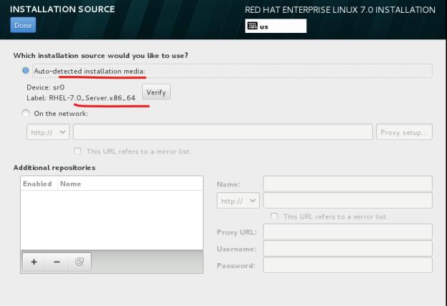
We can select environment type and in the right sight panel we can select os role .
Server with GUI means it will install packages for GUI .
As of now will not select any ad ons
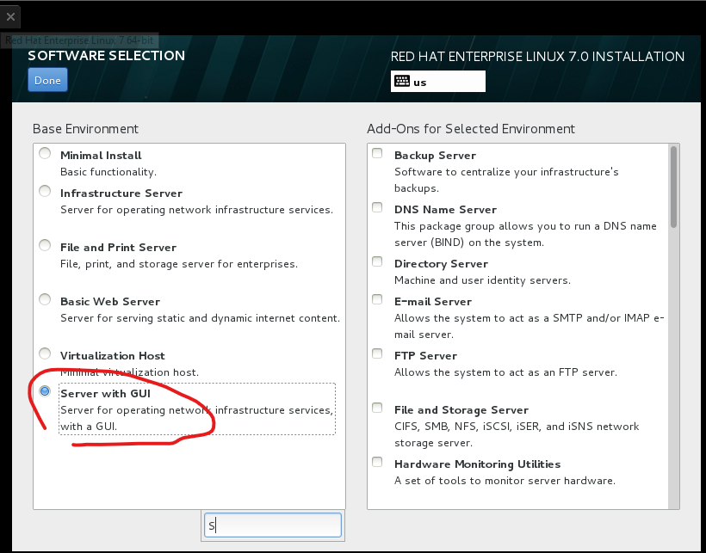

Select disk and chose option “I will configure portioning ”. then select Done
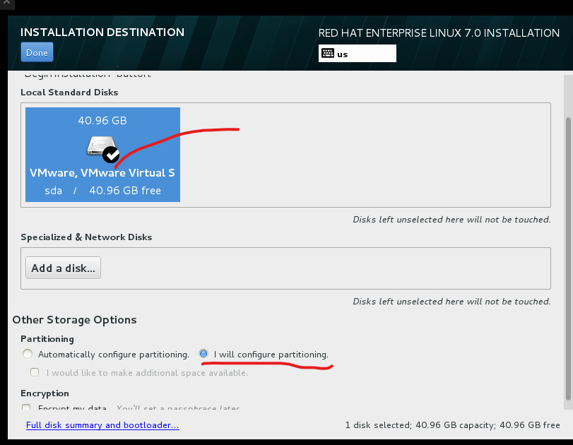
Select LVM and then click on plus symbol to add partions
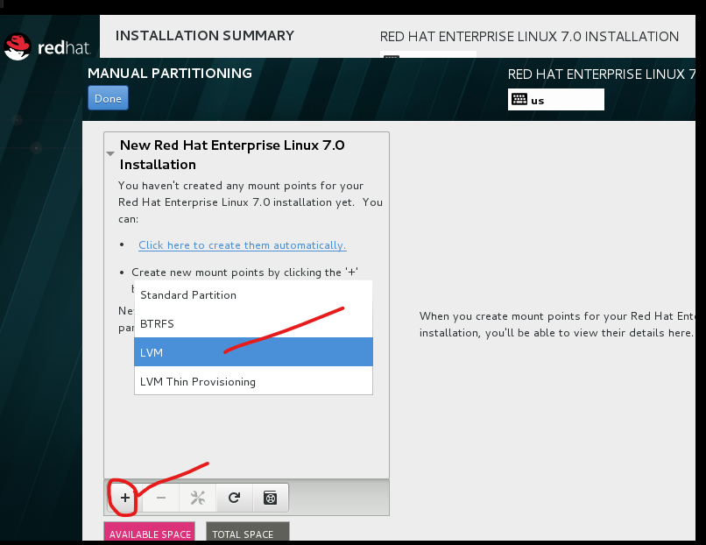

Now add mandotary three partition
/ - > root (12 GB) for file system . then add mount
/boot ->400MB for boot files
/swap -> 8gb for virtual memory .
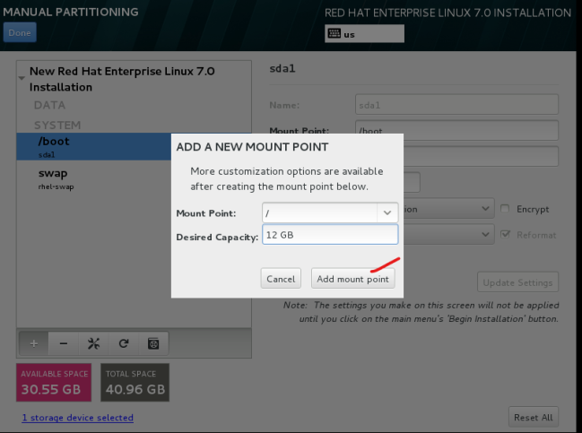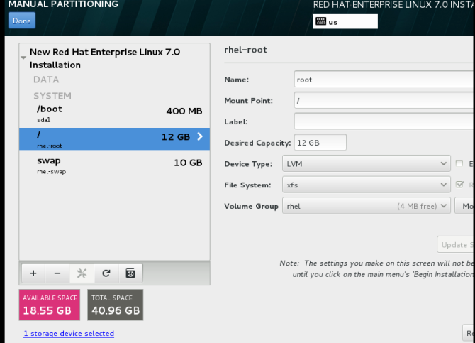
As per requirement you can do other partiotion. Create partion for /home . this will come under DATA.
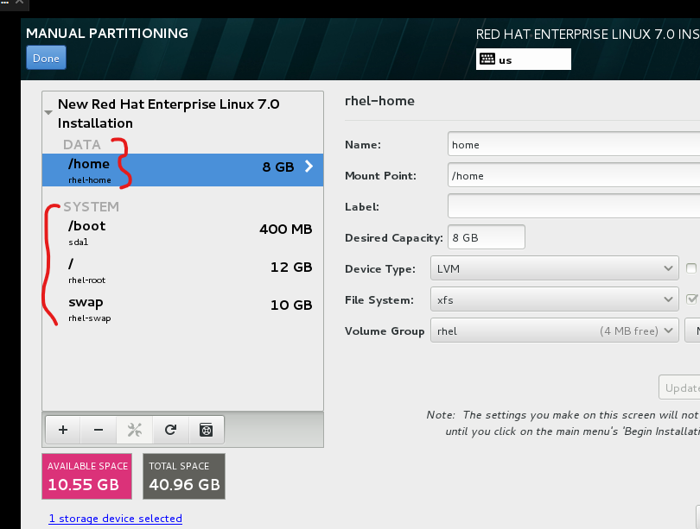

Click done and Accept changes
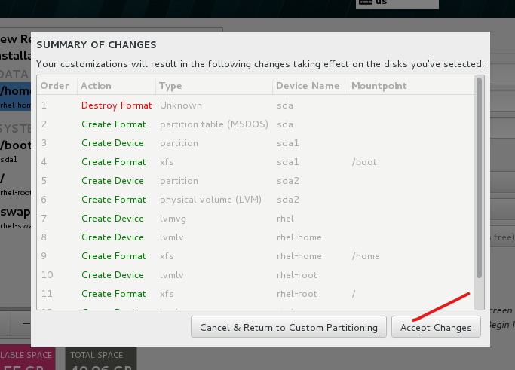
Now select Network and Hostname .
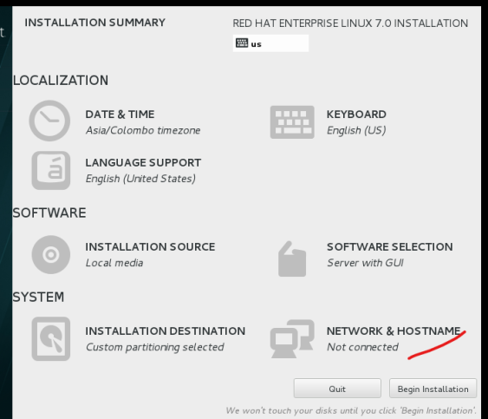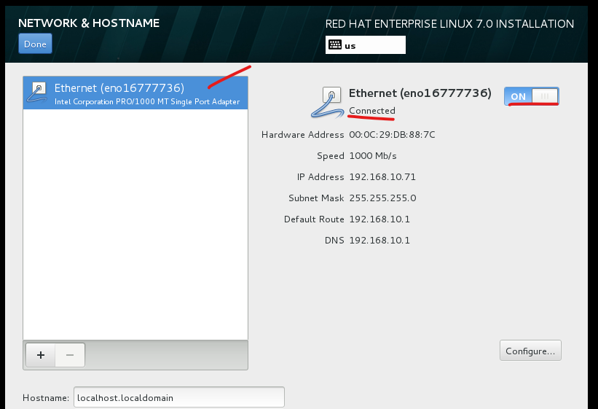
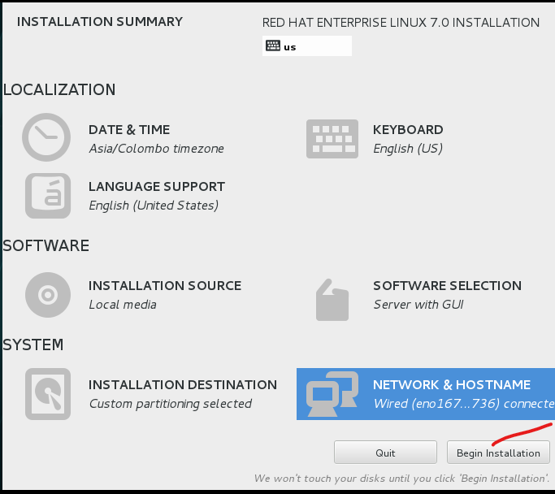
This will take some time to configure.meanwhile configure Root user and normal user
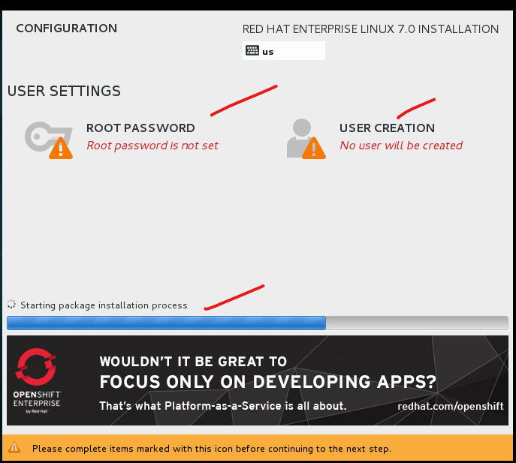
Configure ROOT and remember its credentials .
root – Mukesh@1234
demo – Demo@123
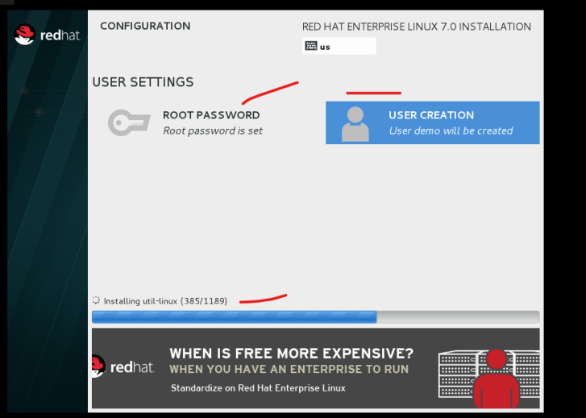

It will take some time to download all configuration file .then reboot the .
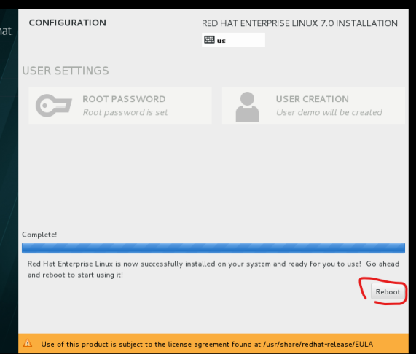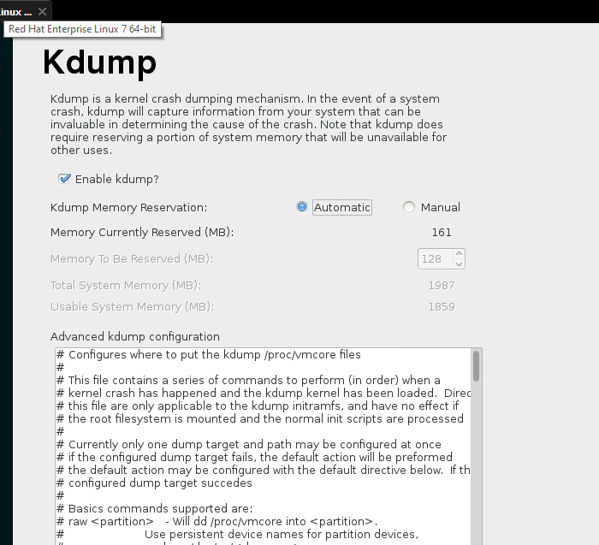
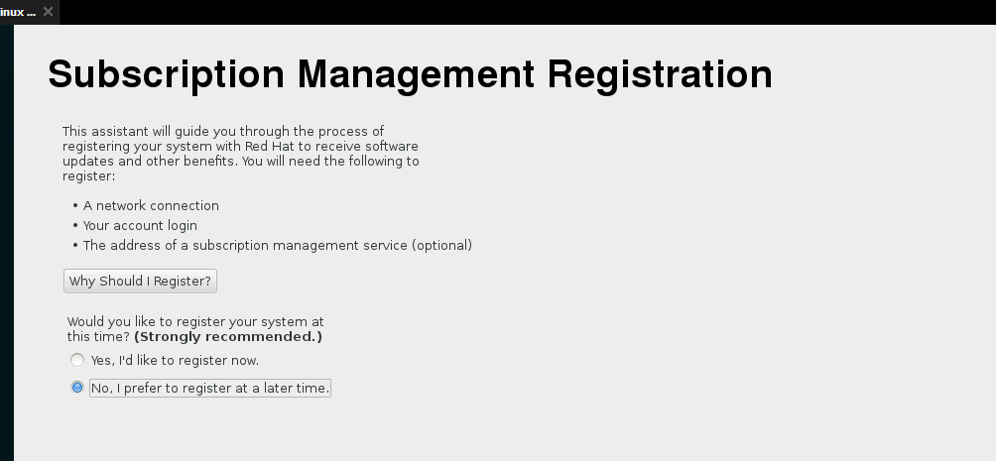
Now you will able to access the server in GUI mode
